**Peshawar:**

Mahabat Khan Mosque

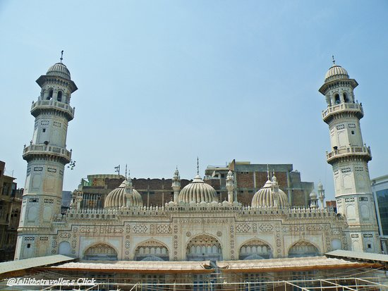

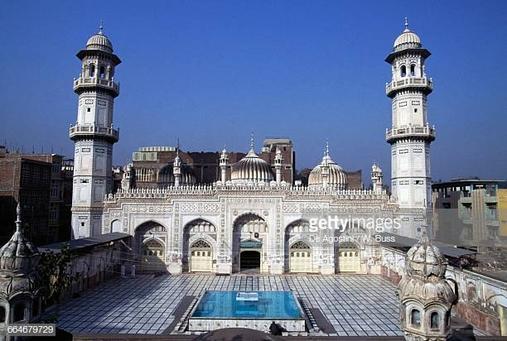

The **Mahabat Khan Mosque** sometimes spelt **Mohabbat Khan Mosque**, is a 17th-century Mughal-era mosque in Peshawar, Pakistan. The mosque was built in 1630, and named after the Mughal governor of Peshawar, Nawab Mahabat Khan bin Ali Mardan Khan, known alternatively as **Mahabat Khan** and **Ali Mardan Khan**. The mosque's white marble façade is considered to be one of Peshawar's most iconic sights. The mosque was built between 1660 and 1670, on what was the highest point in the old city. The minarets of the Mohabbat Khan Mosque were frequently used in Sikh times for hanging prisoners. Five people per day were hanged from the minarets to correspond to the Sunni Islamic practice of praying five times per day, as a substitute for the gallows’.